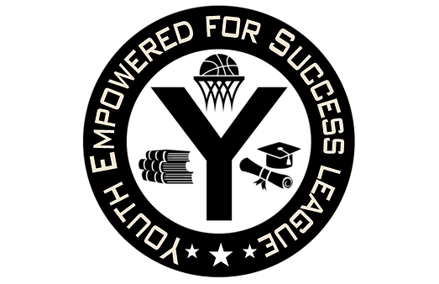

The Youth Empowered for Success Enrichment Program (Y.E.S) is a summer and winter based basketball initiative that helps students gain team-building fundamentals and collective motivation both on and off the court. We believe that providing these athletes with the proper elements of cooperative skill, our students will be able to excel in the Y.E.S. program. We also encourage our students to take our workshops and seminars that cover issues on bullying, self-esteem, cyber bullying, and civil engagement which we believe are our keys to proper discipline, hard work, and dedication that we strive for in our student-athletes.

The Y.E.S League is a section of PARC, a Non Profit 501c 3 Organization. The student-athletes are provided with proper basketball skills and drills by qualified area coaches and basketball trainers. Logistics, scheduling, games, officials, uniforms, clock operators, water, and all conflicts regarding the league are properly handled by the Y.E.S. League members.
The Y.E.S. program provides a safe environment for over 200 Plainfield area student-athletes, with an organization vision of expanding to 300 members in 2017. Through our core values and our mission of empowering our student-athletes, we will be able to not only transform lives but make a difference in our community. Your sponsorship will help with permits, gym rentals, ref fees and other necessary equipment for the league. All Donations are a Tax Write off. Please visit www.yesleague.net to view 2018 sponsors, teams and pictures.

$1,000 - Elite Package
Your Company Logo or name on a Banner to be hung during contest *provided by you
Company name on back of 1 Travel team uniforms
Advertisement on Website, and
Direct Link to your Business
Plaque with Sponsor Name & Team Picture
Sponsor name on the bottom of all Schedules
Team Trophies for 1 division winners (12 trophies) with your company name on bottom

$500 - Championship Package
Your Company Logo or name on a Banner to be hung during contest
Company name on back of 1 team uniforms and Team Named after your company
Advertisement on Website, and
Direct Link to your Business
Plaque with Sponsor Name & Team Picture
Sponsor name on the bottom of all Schedules

$250 - Superstar Package
Team in tournament named after your company
Advertisement on Website, and
Direct Link to your Business
Banner with Business Name will be hung at all games *provided by you

$100 – Slam Dunk Package
Advertisement on Website with
Direct Link to your Business
Business Name on Handouts and sponsor sheet

$75 – Three Pointer Package

Direct Link to Your Business on the website

$50 – Layup Package
Recognition on Website

------------------------------------------------------------------------------------------------------------------------------------------------------------------------------------------------------------------------------------------
Submit Form Below with Payment
***ANY DONATION AMOUNT DIFFERENT FROM A SPONSORS PACKAGE IS MADE IN THIS FORMAT***

Mailing Address:___________________________________________ City:__________________________________________ State:______ Zip:________________

Phone Number:________________________________________ Email:______________________________________________________

Type of Package/Other Dollar Amount:__________________________________________________________

Payment Information: Check#_________________________ Cash Amount___________________________
-------------------------------------------------------------------------------------------------------------------------------
Checks should be mailed to
Terence Johnson
908-456-0258
72 Mariners Court
Plainfield NJ, 07060
Payable to P.A.R.C
DEADLINE is December 2017
